TASK 5 – WAN Technologies

- Create a comparison table listing at least 5 key differences between traditional WAN and SD-WAN, focusing on how data is routed, managed, and secured.
Ans.
Comparison Between Traditional WAN and SD-WAN
Feature | Traditional WAN | SD-WAN
Data Routing | Data follows a fixed path through MPLS or leased lines. | Data is routed dynamically based on network performance and application requirements.
Management | Configuration is done manually on each router. | Managed centrally through a software-based controller.
Security | Security often requires separate firewalls and VPN devices. | Built-in security features such as encryption, VPN, and traffic segmentation.
Network Cost | More expensive due to dedicated MPLS circuits. | Lower cost because it can use broadband, LTE, and MPLS together.
Application Performance | Limited ability to prioritize critical applications. | Automatically prioritizes important applications such as video conferencing and cloud services.
Scalability | Adding new branches requires significant configuration effort. | New sites can be deployed quickly using centralized management.
Visibility and Monitoring | Limited real-time visibility into network performance. | Provides real-time monitoring, analytics, and reporting.

- Draw a simple network diagram (on paper or using a tool like draw.io) showing how SD-WAN connects multiple branch offices to cloud apps (like Office 365 or AWS) and the main data center. Label the SD-WAN controllers, edges, and at least two types of WAN links (e.g., MPLS, broadband).
Ans.

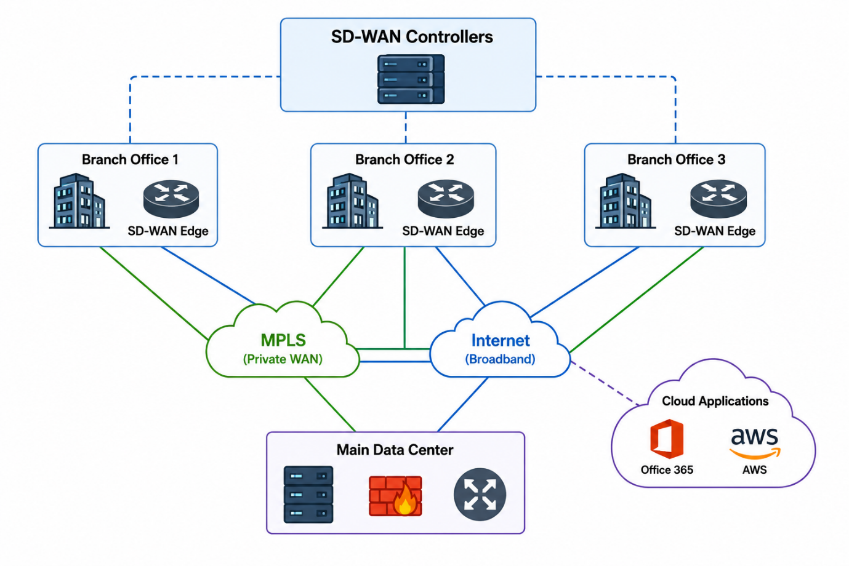

Labels Required -
- SD-WAN Controller → Central management system.
- SD-WAN Edge → Device installed at each branch office.
- MPLS Link → Private WAN connection.
- Broadband Link → Internet connection.
- Main Data Center → Company servers and applications.
- Cloud Apps → Office 365, AWS, Google Cloud, etc.

- Pick any app you use daily (like WhatsApp, Zomato, or Instagram) and write a short scenario explaining how SD-WAN could improve user experience for that app when used across multiple cities in India.<br><br><em><strong>Hint:</strong> Think about speed, reliability, and security when users access the app from different locations.</em>

Scenario: Using WhatsApp Across Multiple Cities in India
- Suppose a person is using WhatsApp to make video calls and send messages between Ahmedabad, Mumbai, Delhi, and Bengaluru. During busy hours, network congestion can cause slow message delivery, poor video quality, or call interruptions.
- With SD-WAN, WhatsApp traffic can automatically be routed through the fastest and most reliable network path available. If one network link becomes slow or fails, SD-WAN quickly switches the traffic to another available link without interrupting the user's call or messages. SD-WAN also uses encryption to protect data while it travels across different networks.

Benefits of SD-WAN for WhatsApp

1. Better Speed
SD-WAN automatically chooses the fastest network path for WhatsApp traffic. This helps messages, photos, videos, and documents reach users more quickly. Even during busy network hours, users experience faster communication with fewer delays.

2. Higher Reliability
SD-WAN provides multiple network connections, such as MPLS and broadband. If one connection becomes slow or fails, SD-WAN automatically switches traffic to another available link. This ensures that WhatsApp messages, voice calls, and video calls continue without interruption.

3. Improved Security
SD-WAN encrypts data before it travels across the network. This protects WhatsApp messages, calls, and shared files from unauthorized access. Users can communicate securely even when accessing the application from different cities and networks.

4. Automatic Path Selection
SD-WAN continuously monitors network performance and automatically selects the best path for data transmission. If one route experiences congestion or high latency, traffic is redirected through a better route. This results in smoother voice calls, better video quality, and a more consistent user experience.

- List and explain three key benefits of SD-WAN for a company with offices in Ahmedabad, Mumbai, and Bangalore. For each benefit, give a real-world example of how it would help employees or customers.
Ans.
Three Key Benefits of SD-WAN for a Company with Offices in Ahmedabad, Mumbai, and Bangalore

1. Improved Network Performance
- SD-WAN automatically selects the best available network path for data traffic. This ensures that business applications run smoothly and efficiently across all office locations.
Real-World Example:
- Employees in Ahmedabad are attending a video meeting with teams in Mumbai and Bangalore. SD-WAN prioritizes video traffic and chooses the fastest route, resulting in clear audio and video without interruptions.

2. Higher Reliability and Availability
- SD-WAN uses multiple network connections, such as MPLS and broadband. If one connection fails, traffic is automatically redirected to another available link, reducing downtime.
Real-World Example:
- If the broadband connection in the Mumbai office goes down, SD-WAN automatically switches traffic to the MPLS link. Employees can continue working without losing access to company applications or customer data.

3. Enhanced Security
- SD-WAN provides built-in encryption and secure communication between branch offices, data centers, and cloud applications. This helps protect sensitive business information from cyber threats.
Real-World Example:
- A customer places an online order through the company's website. SD-WAN encrypts the transaction data while it travels between the Bangalore office and the company's cloud servers, helping keep customer information secure.

